ASSIGNMENT – 4
SOFTWARE DEFINED NETWORKING (SDN)
Practical Implementation using Mininet, Open vSwitch and Ryu Controller

1. Aim
To create and test a Software Defined Networking (SDN) environment using Ubuntu, Mininet, Open vSwitch (OVS) and the Ryu SDN Controller; establish a three-host network, verify connectivity, inspect flow rules and demonstrate traffic filtering.

2. Software and Requirements
- Windows 11 with Oracle VirtualBox and an Ubuntu virtual machine.
- Active internet connection and Ubuntu terminal with sudo privileges.
- Mininet for creating the virtual network topology.
- Open vSwitch for software-based switching.
- Python 3.11 virtual environment and Ryu Controller.

3. Introduction
Software Defined Networking (SDN) separates network control logic from packet forwarding. In this experiment, Mininet creates virtual hosts and a switch. Open vSwitch acts as the software switch, while the Ryu Controller provides the control-plane application. The switch communicates with the remote controller using OpenFlow 1.3.

4. Procedure

Step 1: Start Ubuntu and update the system
Ubuntu was started inside VirtualBox. The internet connection was checked, package information was updated and available system packages were upgraded.
sudo apt update
sudo apt upgrade -y

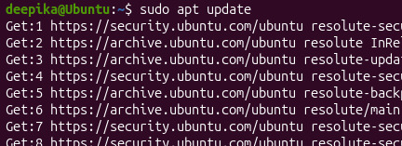

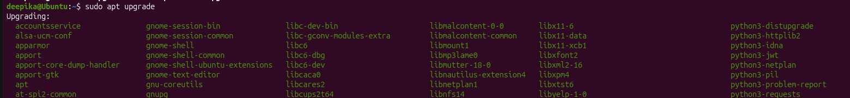

If the Ubuntu mirror returns a 403 Forbidden error, the repository source can be changed to HTTPS and updated again:
sudo sed -i 's|http://in.archive.ubuntu.com/ubuntu|https://archive.ubuntu.com/ubuntu|g; s|http://security.ubuntu.com/ubuntu|https://security.ubuntu.com/ubuntu|g' /etc/apt/sources.list.d/ubuntu.sources
sudo apt update

Step 2: Install Mininet
Mininet was installed using the Ubuntu package manager. Its version was checked after installation.
sudo apt install mininet -y
mn –version

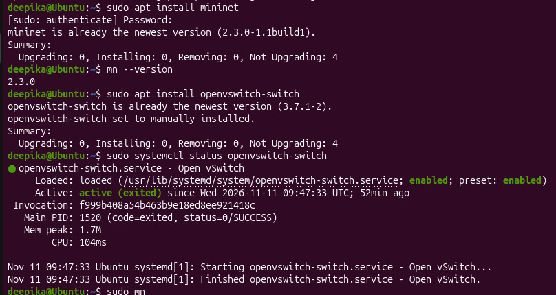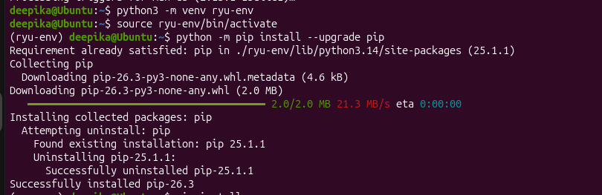

Step 3: Install and check Open vSwitch
Open vSwitch was installed and its service status was inspected. Press q to exit the status screen.
sudo apt install openvswitch-switch -y
sudo systemctl status openvswitch-switch

Step 4: Test the basic Mininet network
A basic Mininet topology was started. The nodes command displayed the available controller, host and switch. The pingall command tested host connectivity. The basic test completed with 0% packet loss.
sudo mn
At the mininet> prompt:
nodes
pingall
exit

Step 5: Install Python tools and create a Python 3.11 environment
Python virtual-environment and pip support were installed. A separate Python 3.11 environment was created for Ryu, leaving the system Python installation unchanged.
sudo apt install python3-pip python3-venv -y
python3 -m pip install uv
uv python install 3.11
uv venv --python 3.11 ryu-env311
source ryu-env311/bin/activate
python –version

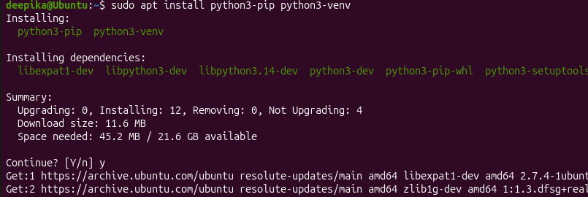

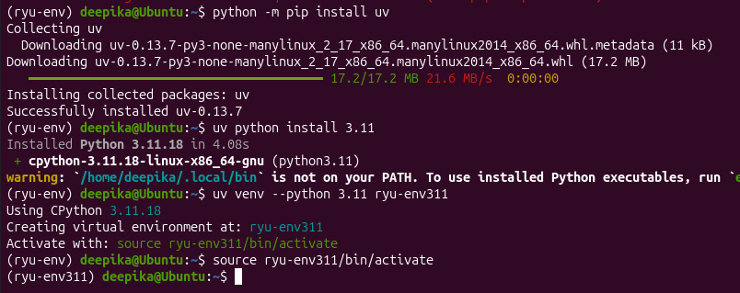

Step 6: Install Ryu Controller

Pip and the required build tools were installed in the Python 3.11 environment. Ryu was then installed and its command-line version was checked.
~/ryu-env/bin/uv pip install --python ryu-env311/bin/python pip wheel "setuptools<58"
python -m pip --version
python -m pip install --no-build-isolation ryu
ryu-manager –version

Step 7: Start the Ryu Controller
The Ryu controller was started in the first terminal using the OpenFlow 1.3 simple-switch application. This terminal was kept open while Mininet was running.
ryu-manager ryu.app.simple_switch_13
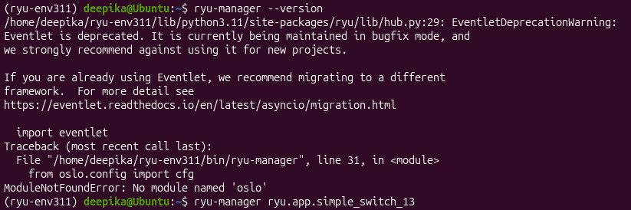

Step 8: Create the three-host SDN topology
A second terminal was opened. The Python environment was activated and Mininet was started with three hosts connected to one Open vSwitch. The remote controller address was set to the local Ubuntu loopback address.
source ryu-env311/bin/activate
sudo mn --topo single,3 --controller=remote,ip=127.0.0.1,port=6633 --switch ovsk,protocols=OpenFlow13

The topology contains hosts h1, h2 and h3 connected to switch s1. The switch connects to the Ryu controller at 127.0.0.1 on port 6633 using OpenFlow 1.3.

Step 9: Inspect nodes and connections
At the Mininet prompt, the following commands were executed. nodes displays h1, h2, h3 and s1; net displays the links between the hosts and the switch.
nodes
net

Step 10: Test connectivity
Connectivity was tested between all hosts and specifically between h1 and h2. Successful replies indicate that forwarding is working.
pingall
h1 ping h2
Press Ctrl+C to stop the continuous ping.
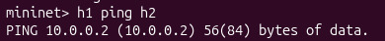

Step 11: Display switch flow rules
A third terminal was opened to inspect the flow entries installed in Open vSwitch.
sudo ovs-ofctl -O OpenFlow13 dump-flows s1

Step 12: Add a traffic-filtering rule
A high-priority drop rule was added to switch s1. It drops packets entering the switch through input port 1. In this single-switch topology, port 1 is connected to h1.
sudo ovs-ofctl -O OpenFlow13 add-flow s1 "priority=100,in_port=1,actions=drop"

Step 13: Test the filtering rule
The h1-to-h2 connectivity test was repeated from the Mininet prompt. Packet loss is expected while the drop rule is active because packets entering through port 1 are dropped.
h1 ping h2

Step 14: Remove flow rules and clean Mininet
The flow entries were removed. Mininet was exited and its virtual interfaces and processes were cleaned up.
sudo ovs-ofctl -O OpenFlow13 del-flows s1
# At the mininet> prompt:
exit
# Back at the Ubuntu terminal:
sudo mn -c

5. Terminal Arrangement
Terminal | Purpose
Terminal 1 | Runs the Ryu controller and remains open.
Terminal 2 | Runs the Mininet topology and host connectivity tests.
Terminal 3 | Displays, adds and deletes Open vSwitch flow rules.

6. Observations
Test | Observation
Basic Mininet test | Default Mininet topology started and nodes were displayed.
Basic connectivity | Initial pingall test completed with 0% packet loss.
Three-host topology | The intended topology contains h1, h2, h3 and s1, controlled remotely by Ryu.
Flow inspection | dump-flows displays the flow entries present on s1.
Filtering | The priority-100 drop rule blocks packets entering through port 1.
Cleanup | del-flows and mn -c remove flow entries and clean up Mininet.

7. Result
An SDN environment was set up using Mininet, Open vSwitch and the Ryu Controller. A three-host topology was created with one Open vSwitch, host connectivity was tested, flow rules were inspected, and a traffic-filtering rule was added and tested. The Mininet environment was cleaned after the experiment.

8. Conclusion
The experiment demonstrates the basic working of Software Defined Networking. Mininet provides the virtual network, Open vSwitch performs packet switching, and the Ryu Controller manages forwarding behaviour through OpenFlow. The drop-flow rule demonstrates how traffic can be filtered by installing a rule in the switch.

